GEOGRAPHY AND TIMESTAMP OF SPAM TWEETS

CSCE 5290

NATURAL LANGUAGE PROCESSING

PROJECT INCREMENTAL 1

GROUP 7

**Github source:**

[**https://github.com/anith462/Anis462**](https://github.com/anith462/Anis462)

**Instructor: Dr. Zeenat Tariq (**[*Zeenat.Tariq@unt.edu*](mailto:Zeenat.Tariq@unt.edu)**)**

**GROUP MEMBER’S:**

1. Anitha Nari - 11550658
2. Vijayalakshmi pepala - 11656632
3. Monisha Mahitha boddu - 11513712
4. Mounika nuchu - 11653658

**INDEX**

Motivation

Significance

Objectives

Features

Related Work (Background)

Dataset

Features

Analysis

Implementation

Preliminary Results

Project Management

Implementation status report

References/Bibliography

**Motivation:**

Twitter stands apart from other online social networks due to its distinctive friend-following and posting features. One the one hand, friendships on Twitter aren't always reciprocal. Users can "follow" celebrities, for instance, without expecting them to do the same. On the other hand, tweets or microblogs, which are text posts on Twitter, are limited to 140 characters. Users are encouraged to often but indiscriminately post on everything, including feelings, pursuits, opinions, local news, etc. Due to the narrow definition of sentiment analysis as the Natural Language Processing (NLP) task that classifies a text as positive or negative, the terms polarity detection and sentiment analysis are frequently used synonymously. Each geo-tagged tweet's categories of adjacent locations were vectorized using one-hot encoding and frequency count encoding.

Each geo-tagged tweet's adjacent location was vectorized as an ego network as well. After that, the vectorized location and word embeddings were combined, and they were input into the CNN and BiLSTM networks to train and categorize the sentiment labels of the tweet. According to the experimental findings, our method outperformed using just word embeddings in terms of classification performance.

**Significance:**

The importance of determining the location and time stamp of spam tweets is multifaceted:

Spam campaign localization: Identifying the region of spam tweets makes it easier to determine the origin of spam campaigns. This data can be used to restrict spam from specific geographic areas or IP addresses.

Targeted attacks are frequently used by hackers to exploit vulnerabilities in certain countries or time zones. Security professionals can predict such assaults and take preventive measures by recognizing the geography and timing of spam tweets.

Spam trend analysis: Researchers can uncover trends and patterns in spam campaigns by studying the location and timing of spam tweets. This information can be utilized to create more effective spam countermeasures.

**Project Introduction:**

In psychology, the terms sentiment and emotion are sometimes used interchangeably. Sentiment is a mental attitude that is founded on an emotion, whereas emotion is a unique feeling. However, this distinction is rather hazy, which also applies to the line separating sentiment from opinion. Type, valence (positive, neutral, and negative), and intensity are three components that make up sentiment. It's vital to keep in mind that the thing to which such a sentiment can apply can also change a lot. Sentiment analysis can therefore be carried out at various granularities, i.e., in terms of whole texts, phrases, or items, such as individual words. Like other machine learning strategies, there are supervised (like straightforward decision trees) and unsupervised techniques. Recent years have seen profound.

**Objective:**

Because tweets are brief and noisy, it is difficult to predict where people will be when they will tweet or go home. It is customary to use location- and tweet-specific methods and information while implementing recognition and disambiguation procedures for formal papers.

In this project, we developed a context-dependent sentiment classifier by combining the sentiment analysis of various authors, locations, times, and dates as determined by tagged Twitter data with conventional word-based sentiment classification methods. As far as we can determine, this hasn't been accomplished by major prior work on Twitter sentiment classification.

**Features**:

We can check for a number of features in the data to determine the location and timing of spam tweets, such as:

Some social networking networks allow users to geotag their tweets, or add location information to them. This information can be used to pinpoint the location of spam tweets. IP addresses: Each internet-connected device has a distinct IP address. IP addresses can be used to pinpoint the location of the machine that issued the spam tweet.

Timestamps: Social media sites often keep track of the day and hour that a tweet was published. This information can be used to determine the timestamp of spam tweets.

Text analysis: Examine the text of the spam tweets for patterns or phrases that may indicate the location or timestamp. Spam tweets advertising a local event, for example, may suggest a specific region, but spam tweets advertising a limited-time offer may suggest a specific timestamp.

Language analysis: we can also use language analysis to determine the location or timestamp of spam tweets. For example, if the spam tweets are written in a language that is only spoken in one location, we can deduce that the tweets originated in that region.

By integrating these characteristics, we may create a machine learning model that can correctly detect the location and time stamp of spam tweets.

**Dataset:**

The dataset contains the information of the tweets, Timestamp, dates, location, username, user description, user friends, user followers, user tweets, hashtags, source.

The link of the dataset where it is uploaded is shown below in

<https://www.kaggle.com/datasets/anithanari/geographyandtimestampofspamtweets>

**Dataset Image:**

The below image shows some part of the dataset-

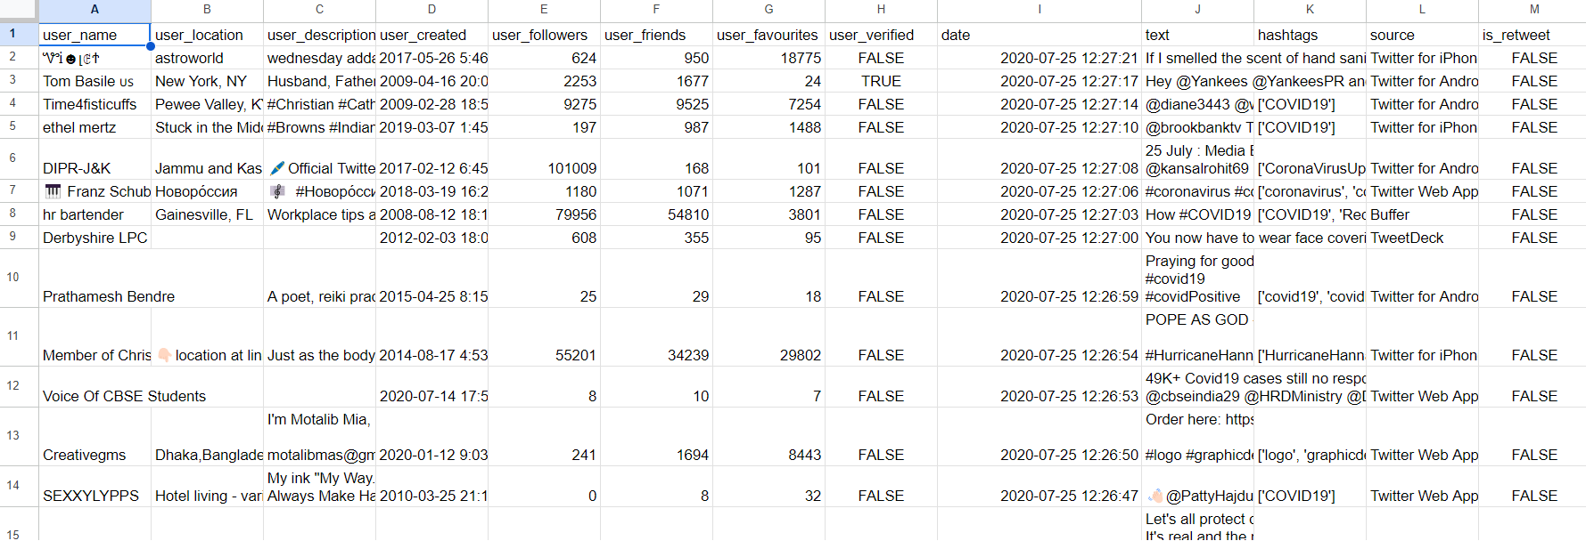

**Sentiment Analysis of Data:**

In this project the tweets which are provided in the dataset are preprocessed and cleaned. The data need to be divided based on training data and test data. We have used Naive Bayes classification model for this project. The tweets are determined if they are spam or not. Based on the results the sentiment analysis is performed.

**Future Work:**

The main aim of this project is to find whether the tweets are spam or not, if it is a spam tweet then corresponding location, what kind of the tweet is it and its timestamp should be given to the user.

Our team is on a plan to use different Natural Language Processing techniques(Lemmatization, tokenization) and also Machine learning processes like logistic regression.

Also planning to implement more new features to the existing projects.

**Flowchart:**



The above flow chart shows the steps involved in the geolocation and timestamps of the spam tweets. The Original tweets are first pre-processed(unwanted or stop words are removed), the next step is the tokenization and classification and finally the input data undergoes sentiment ranking.

**Sentiment Analysis:**

We have worked on the dataset of spam tweets from different sources of Github, Kaggle and made them into a single dataset.

Input:

Textual material that has been tokenized, padded, and represented as sequences of integers makes up the input data. The sequence of tokens used to represent each input text serves as one of the features needed to train the models. The pad-sequences method is widely used to ensure that all the numerical sequences are of the equal length once the text has been tokenized into number sequences.

Output:

If the results are not what are expected, the data may not be properly represented or the models may not be learning the underlying patterns in the data. Another possibility is that the models are too simple to adequately reflect the subtleties of the data.

Explanation: A recurrent neural network (RNN) and a convolutional neural network were both utilized in the code blocks. (CNN). The CNN model is a superior choice for NLP jobs since it can develop order-wise representations of the input data given by using filters of convolutional on the text. The RNN model, wheres at the other end, is a wise choice since it can identify patterns in a sequence in the input data. The models appear to be suitable for the work at hand, although other models, such as transformer-based models like BERT, may perform better. The size of the dataset provided and the hardware which is present for the various types of models' training, however, also play a role in the model selection process.

**Preliminary Results:**

**Functions for code, tokenize, sentiment Analysis**

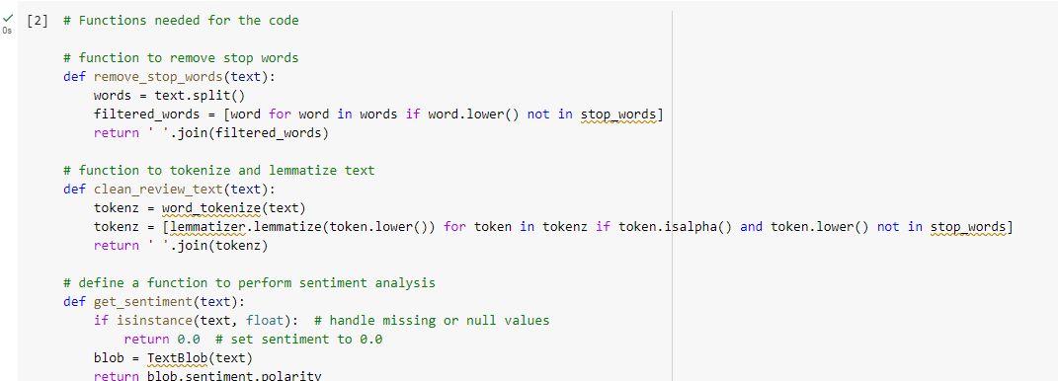

**Loading of Dataset**

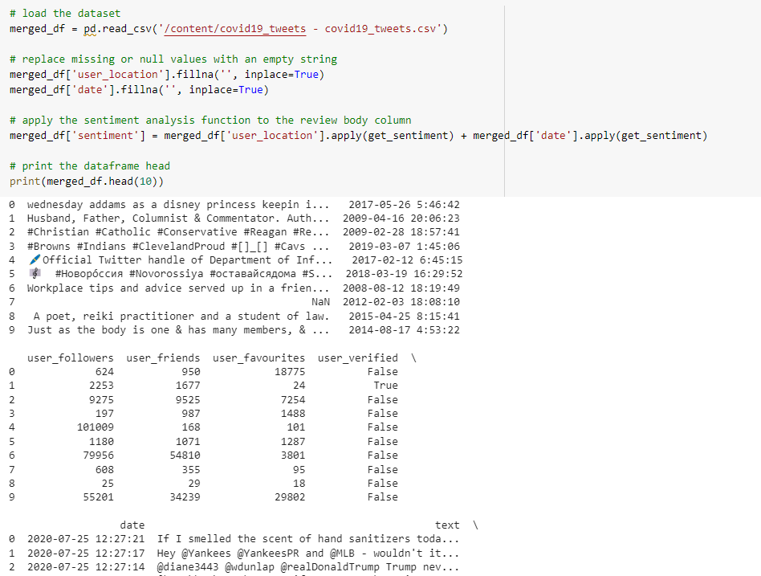

**Cleaning of tweets for further analysis and generating cloud**

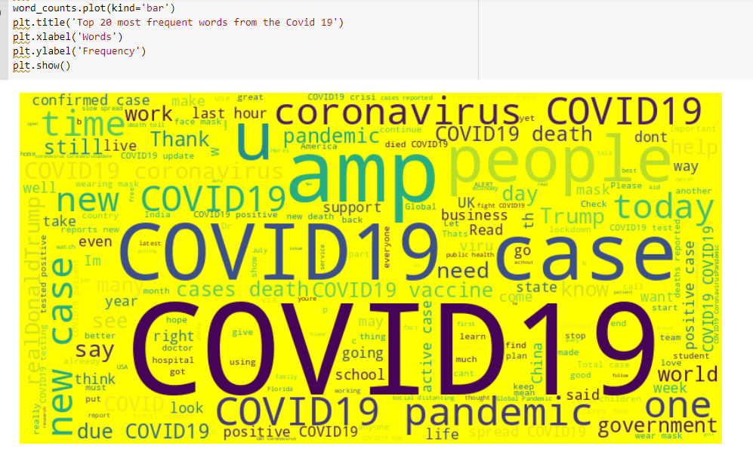

**Generating Bar graph**

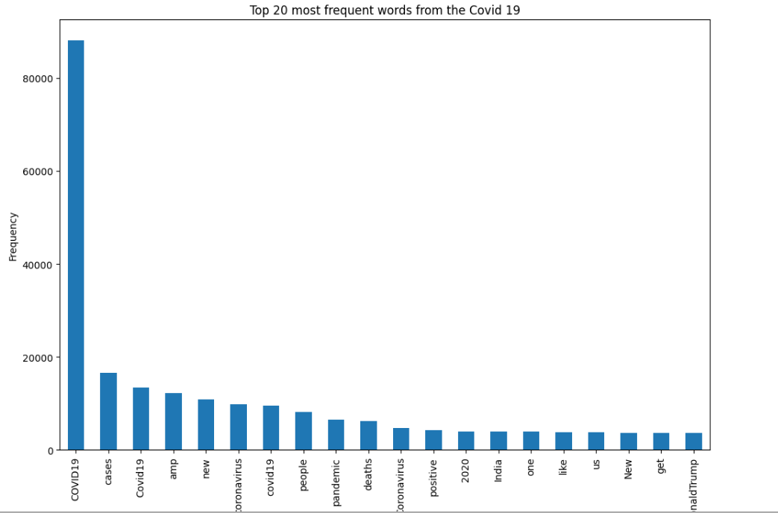

**Positive and negative tweets**

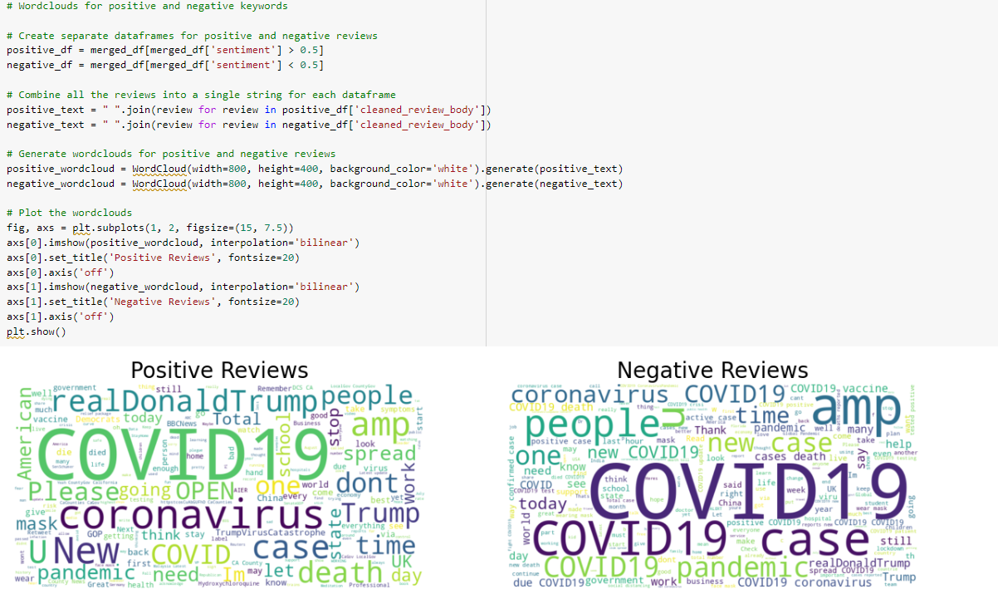

**Generating Positive and negative tweets in Pie chart**

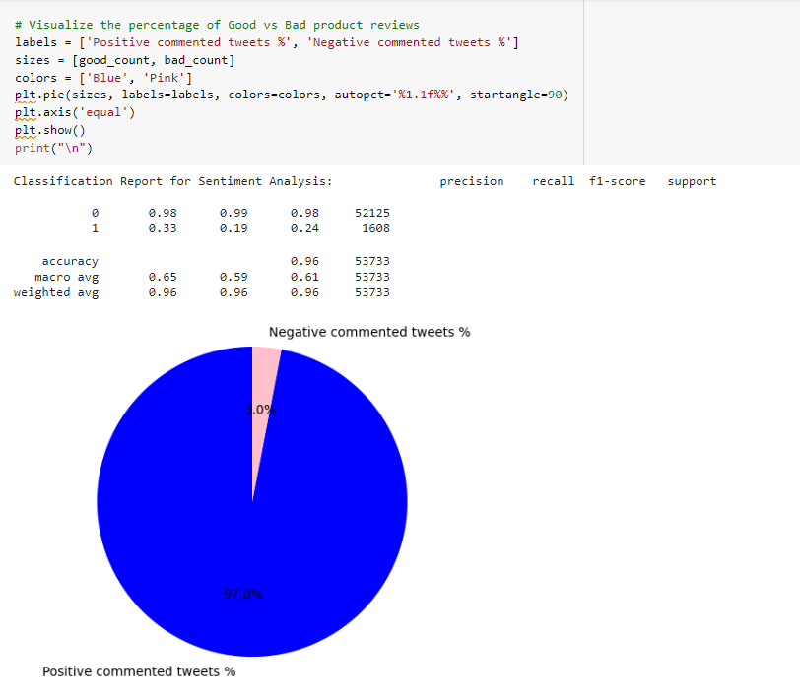

**What are the Impacts of Spam Tweets:**

Identifying the location and time stamp of spam tweets can have a number of consequences for the spam itself:

By identifying the location and time of spam tweets, it is possible to ban messages coming from specified locations or IP addresses. This may result in a reduction in the overall volume of spam communications.

Machine learning systems can better recognize and classify spam communications by using location and timing information. This can improve spam detection accuracy and reduce the number of false positives.

Researchers can uncover trends and patterns in spam campaigns by monitoring the location and timing of spam tweets. This information can be utilized to create more effective spam countermeasures.

**Challenges of Spam Tweets:**

Because spam tweets can be posted in a variety of languages and often employ slang or unconventional grammar, it can be challenging to create filters that are successful. Often contextual in nature, spam tweets attempt to imitate real tweets. Fast-changing circumstances make it possible for spammers to quickly alter their strategies in order to avoid being discovered. It can be challenging to recognize and evaluate every tweet for spam because of the vast number of tweets that are produced every day. Spammers frequently hide their URLs by using link shorteners. Without clicking on the link, it can be difficult to determine its purpose. It is challenging to use an account's age or reputation when dealing with spam tweets because they might come from both new and established accounts.

**Video Link:**

[**https://www.youtube.com/watch?v=Ow5UDUKU_Nk**](https://www.youtube.com/watch?v=Ow5UDUKU_Nk)

**Project Management:**

All the team members has worked on multiple tasks and gathered the code and required information for the project.

| **Name** | **Participation** |
| --- | --- |
| Mounika | Gathered the dataset for the tweets which are spam and source code  25% |
| Anitha | Performed the Dataset pre-processing and generated the graphs: bar graph and pie chart.25% |
| Monisha | Worked on positive and Negative dataset of tweets. 25% |
| VijayaLakshmi | Worked on the report of the project, explored the features and significance. 25% |

**Conclusion:**

Rich context is provided with each tweet. These contain user profiles' various features as well as the timestamps and geo-tags attached to tweets. The ability to infer tweet and home locations at a coarse granularity using temporal information, such as user-declared timezones and tweet timestamps, is one of them. In order to distinguish between the above places and other types of entities, geo-tags and timestamps have also been shown to be useful. Finally, we connect LBSN-based POI recommendation and semantic location prediction for tweets. We see that LBSN-based POI recommendation models spatio-temporal parameters more intricately.

**References:**

1. <https://github.com/shuber/postgres-twitter>
2. <https://www.google.com/imgres?imgurl=https%3A%2F%2Fwww.mdpi.com%2Fsymmetry%2Fsymmetry-12-01054%2Farticle_deploy%2Fhtml%2Fimages%2Fsymmetry-12-01054-g002.png&imgrefurl=https%3A%2F%2Fwww.mdpi.com%2F2073-8994%2F12%2F6%2F1054&tbnid=-w-6jB-C5VS6VM&vet=12ahUKEwiu3e6X4ar9AhXVAFkFHZuUD5MQMygCegQIARAp..i&docid=hNCDeG7q65SD1M&w=2274&h=1977&q=tweets%20sorted%20by%20geography%20and%20timestamp%20project%20in%20nlp&ved=2ahUKEwiu3e6X4ar9AhXVAFkFHZuUD5MQMygCegQIARAp>
3. W. McKinney, ‘‘Data structures for statistical computing in Python,’’ in Proc. 9th Python Sci. Conf., Austin, TX, USA, 2010, pp. 51–56.
4. T. E. Oliphant, A Guide to NumPy, vol. 1. New York, NY, USA: Trelgol, 2006